Welcome

Dear Parents

Welcome to Sheldwich Primary School! We are very proud of our school, which has served the local community since at least 1868. We hope this prospectus gives you a glimpse of life here and answers any questions you may have about our aims, curriculum and school ethos.

I am sure that when you visit us you will see for yourself that we provide a positive, caring and stable environment whereby your child is able to grow and develop a sense of responsibility and independence. High standards of work and behaviour are expected and we encourage our children to give their best in education, recreation and social activities. We aim to provide children with an education that is broadly based and tailored to meet their individual needs.

In order to be successful, it is important for parents, school staff and governors to work closely together. We are always willing to discuss any matter relating to you child’s development, progress or happiness; and in turn share the successes of your children with you. We value your interest and support.

We welcome the opportunity to show you around our school and are always pleased to answer any questions you may have. If your child is joining us, we extend a warm welcome and look forward to working in partnership with you over the coming years.

Yours sincerely

Sarah Garrett
Headteacher

MISSION STATEMENT

At Sheldwich Primary School we believe in maintaining consistently high standards
of work and behaviour in a happy and caring environment.

Aims

- We aim to maintain a clear and continuing focus of teaching and learning with rewards and incentives to encourage children to succeed.

- The school actively promotes the development of pupils’ spiritual, moral, social and cultural awareness, fostering attitudes of tolerance and respect which ensures every member of the school community feels important and valued.

- We endeavour to provide extra curricular activities which, where possible, will include the wider community and will encourage parental involvement and support.

- We advocate equal opportunities at all levels.

- We believe in strong positive leadership by the head and senior staff thus ensuring a supportive structure and effective teamwork throughout the school.
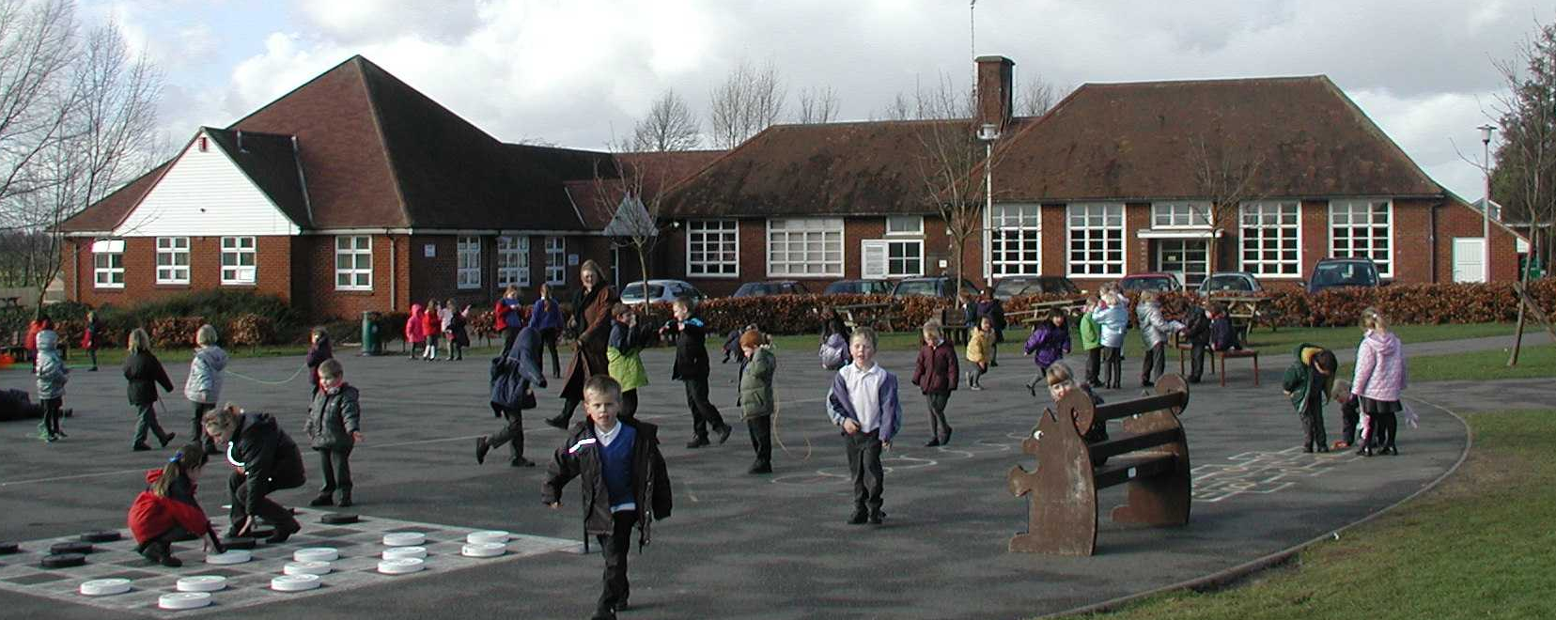
FACILITIES

The present Sheldwich School was opened in 1940. Because of rising rolls a school extension was completed in 1994, offering classrooms, resource areas, an administration centre and improved parking facilities. A further extension was added in 2006 giving the school extended conference facilities. In July 2012 we completed the refurbishment of the junior cloakrooms and the construction of another classroom, which has replaced the mobile classroom. During the next two years we are hoping to redecorate the older part of the school.
The school is situated in a rural conservation area, and yet is easily reached from Faversham. We have extensive playing fields including a range of environmental areas.

AIMS OF THE SCHOOL

Our principal aim is to develop each child to the maximum of his or her potential in all areas of the curriculum. This is undertaken by matching tasks to pupils’ ability and having high expectations of all children throughout the school.

We also encourage each child to develop into a good citizen, aware of his or her social responsibilities, and to find pleasure in working as a member of a social group. Children are taught to respect others within the school community.

Good behaviour has an important part to play in the smooth running of the school and in personal development. We encourage good behaviour through positive rewards such as achievement certificates, acknowledgement and praise, and Headteacher awards. In the occasional cases where a pupil's behaviour gives cause for concern we work with parents to plan for improvement. Bullying and behaviour which disrupts other children's learning and enjoyment of school are not acceptable, and are dealt with in partnership with parents.

We encourage self-management and independence so that children develop responsibility for completing their learning tasks. We teach through a blend of class, group and individual work. We aim to provide a happy, caring environment in which children are motivated to do their best. This is achieved by organising a consistent approach throughout the school and providing a secure framework in which children can grow in personal and academic confidence.

Finally we try never to lose sight of the wonder of life and of the world around us, and the inspiration to be found in human achievement. We hope to instil in our pupils a respect for life and a spirit of enquiry.

In all of these aims parents have an important role as partners with the school. We look forward to working with you.
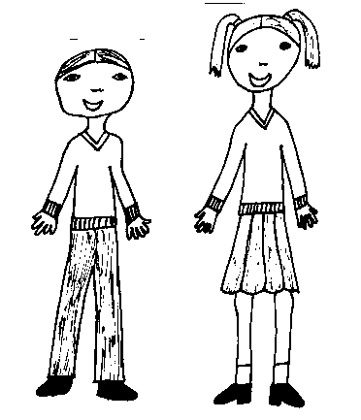
SCHOOL UNIFORM

A feeling of school unity is enhanced by the wearing of a uniform and we strongly encourage you to support us. All garments can be bought from Term Time Uniforms in St Mary’s Road, Faversham. Jumpers, cardigans, polo shirts, PE shirts and other items, all with the school name embroidered on them are available. A list of school uniform can be found in the information section at the end of this prospectus.
Please ensure that every part of your child's uniform, PE kit and equipment is clearly labelled with his/her name.

We ask that children wear sensible black shoes, not trainers, and that for safety reasons long hair is tied back and no jewellery is worn, however the children may wear a watch. For the same reason we ask that studs only are worn in pierced ears. These need to be left at home on days when PE or sports activities take place, or removed before the lesson. Nail varnish should not be worn in school and hair colourings should be saved for use during the holidays.

HOMEWORK

Children are expected to work hard during lesson times and therefore deserve homework which is stimulating and relevant.
The sort of homework that your child will bring home is:

Class R: reading, repeating nursery & counting rhymes, counting, reinforcing letter sounds, reading key words,

Classes 1 & 2: reading, repeating nursery and counting rhymes, spelling activities, Numeracy and Literacy activities

Classes 3 & 4: reading, spelling activities, tables, Numeracy and Literacy activities, topic based work

Classes 5 & 6: reading, vocabulary work, spelling activities, Numeracy and Literacy tasks including research

Parents can help by supporting the learning of spellings and tables, checking the presentation of work and reading to their child. School reading books are only one small fraction of the range of suitable reading matter that children can and should be encouraged to access and enjoy. Work which should have been finished in class time may also be sent home for homework.

Remember to praise your child's efforts with the work he or she brings home.

At the end of every term your child will bring home a Progress Report. This gives you information on their progress for the previous term and also lists their targets for the following term. Targets should help improve the quality of work. Please work on these with your child at home.

PARENTS AS PARTNERS

Having read this far you will appreciate that Sheldwich School values the support of parents as vital to the well-being of the school and its pupils. A constructive relationship between school and parents improves the quality of learning for your child.

When your child starts school you automatically become a member of the Parent Teacher Association. We hope that you will support this thriving organisation and help to raise funds for the school while enjoying the social contacts with other parents which it offers. Types of events that are held include fetes, Easter egg hunt, Spring Ball and various parties.

There are parent consultation appointments in the Autumn and Spring when pupil targets are discussed. At the end of Term 6 there is an informal open evening following the issuing of reports.

We run a range of workshops where parents are invited in to learn more about our school curriculum. You will be informed about these in our newsletters and on our school website www.sheldwich.kent.sch .

We prefer parents to communicate with one of the school secretaries at the beginning of the day, as teachers are busy at this time. You are welcome to talk to class teachers after school but it is advisable to make an appointment as they sometimes have other meetings to attend.

If you experience any anxieties about your child or anything connected with the school please be sure to make an appointment at the earliest opportunity so that the situation can be discussed and resolved. We would also ask that you contact us if events external to the school are likely to be having an adverse effect on your child's school life.

We are very fortunate at Sheldwich school in having plenty of parental support in the classrooms, and you would be very welcome if you would like to help in this way. Parents mainly support such activities as, reading, taking children through computer programs, cooking with small groups and art and craft work. We welcome any skills that you might be able to offer the school. If you would like to help on a regular basis you will be asked to apply for a CRB enhanced disclosure but we can give you more information about this at the time.

STARTING SCHOOL

We want your child to make a successful transition between home and school. There are several ways in which you can help us achieve this.
- Please allow enough time in the mornings for your child to learn to dress him or herself, learn to tie laces and cope with zips.
- Please make sure that your child can manage to go to the toilet on his or her own and knows the importance of washing hands afterwards.
- Please give your child plenty of practice at using a knife and fork.

Confidence on these social points will help your child's self-esteem.

We also expect that by the time your child arrives at school he or she will have learned a basic sense of right and wrong, and will have been taught an appropriate respect for others and for authority.

Your child will have experienced at least one "taster" session in school during Term 6, before starting school in the Autumn. There will also be an introductory meeting for parents in the school hall and a visit by the class teacher to your home to discuss any concerns you may have regarding your child’s first experience of school.
We will aim for your child to be attending school full-time by week 3, however, should a child not be ready to start full time this can be discussed with the class teacher.

ENTRY TO SECONDARY SCHOOL

During the last year at primary school parents will need to consider which secondary school they would like their child to attend. There is a selection procedure and children sit a range of tests which they need to pass in order to transfer to a grammar school.
Discussion of the selection procedure with the Headteacher and class teacher will take place towards the end of Year 5 and the testing takes place at the start of Year 6.
There is a wide range of local Secondary schools and we hold some of their prospectuses at school for parents to take. Every year parents of Year 6 children are offered the opportunity to visit the local Secondary schools to assist them in making their choice.

CURRICULUM

We aim to provide a quiet, purposeful working environment in which children progress at a pace that is appropriate for them. We place an emphasis on Literacy and Numeracy skills, as these are the foundations required for all other subjects.
Staff work as a team so that children experience continuity of curriculum delivery throughout the school. Whole-school schemes of work are used and children are taught in a combination of class and group lessons. Schemes that we use include RM Maths, Oxford Reading Tree, Soundswrite and cursive handwriting.

National Curriculum assessment takes place at the end of Key Stage 1, when children are in Year 2 and at the end of Key Stage 2 when children are in Year 6. In addition the school undertakes internal assessment of children so that progress can be monitored.
Your child will have an active part in the National Curriculum which covers Numeracy, Literacy, Science, Religious Education, ICT, Geography, History, Art, Technology, Music, PSHE, Physical Education and French as well as a wide variety of experiences to enrich their learning.

If you have any queries about the curriculum the most useful person to talk to is the class teacher who can explain the way in which the curriculum is presented and delivered. If you are still concerned please make an appointment to meet the Key Stage Leader. If your concerns are still not answered you will need to meet with the Headteacher who will need to look into the matter on your behalf.

HEALTHY SCHOOLS

We are engaged in the National Healthy Schools Programme which aims to support children and young people in developing healthy behaviours; to help raise pupil achievement; to reduce health inequalities and to help promote social inclusion.
The core subject themes of this programme are PSHE, Healthy Eating, Physical Activity and Educational Health and Well Being.
Our whole school approach to these themes is to develop an ethos and environment that supports learning and promotes health and well being of all. We aim to work with the support of our local community in targeting and addressing society related issues such as drug awareness, anti bullying and healthy lifestyles. We also have whole school policies aimed at promoting the well being of all children, such as provision for gifted and talented, social inclusion, bullying and eco schools.
It is expected that if you choose Sheldwich Primary School, you will support us in encouraging a healthy lifestyle for your child both in and out of school.
RELIGIOUS EDUCATION

Although work on Christianity is covered in both Key Stages and the Foundation Stage, there will be work in depth on other world religions. Teaching will seek to bring about a deeper knowledge and understanding of religious traditions but also to develop a range of skills such as the ability to empathise and evaluate attitudes and respect for diversity.

From the time of the 1944 Education Act, parents have had the right to withdraw their children from Religious Education. The school must comply with any request from a parent to withdraw their child and parents are not required to give their reasons for wanting to do so. If you would like to withdraw your child from Religious Education, please make an appointment to see the headteacher.

SPECIAL AND ADDITIONAL NEEDS

At any one time an average of 20% of children within any Primary school may be experiencing problems that could be called special educational needs. These can range from very slight difficulties that do not take long to rectify, to more severe learning difficulties which require a longer-term plan of action. Additional Education Needs provision within the school is supported by external services. We also are very aware of children who are gifted and talented. Advice can be sought from our AENCO (Additional Educational Needs Co-ordinator) and/or from outside agencies. Pupils are extended through differentiation and in some cases, extra provision. All of these matters will be discussed with you as parents. All parents are welcome to read our school policies on Special Education Needs, Additional Educational Needs and Inclusion issues.

PERSONAL AND SOCIAL DEVELOPMENT

It is the duty of the Governors to agree a policy concerning the teaching of sex education within the school. We feel that sex education should be approached as an aspect of the wider subject of personal and social education. Sexual matters are discussed within the context of the emotional, physical and social changes they will experience as they enter adolescence. Please refer to our Sex Education Policy for further information or see the Headteacher.

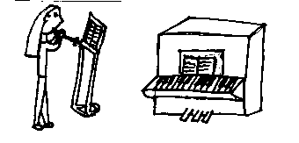
EXTRA-CURRICULAR ACTIVITIES

We are very grateful to our teachers and parents who help with these activities. At present there are 9 clubs including football, netball, infant sports, art, chess, nature, choir, and healthy eating. Lessons in piano are taught by a private tutor and children also receive violin tuition from Kent Music School.

INTER-SCHOOL ACTIVITIES

The local schools combine for several events during the course of the year. Sports matches and tournaments take place against other schools. We hope that children will give of their best in these team activities and learn to be gracious in both victory and defeat.

SWIMMING

We believe that swimming is an important part of the curriculum, not only as a life-saving skill but as an activity that can become a healthy leisure pursuit in adult life. It provides a distinctive form of physical activity which allows children to gain confidence and self-esteem. During Terms 1 & 2, Class 5 & 6 children are given the opportunity to go swimming and during Terms 3 & 4, it is the turn of Classes 2 & 3.

We ask parents to make voluntary contributions towards the cost of these lessons, to cover the costs of the instructors and the coach.

DAY TO DAY RUNNING OF THE SCHOOL
In this section we are including all the day to day details of school life with which we request cooperation. The following details do help with the smooth and efficient running of the school.

TIMES

Start of School Morning Break Lunch time Afternoon break End of School

INFANTS 8.55am 10.15 – 10.30am 12.00 – 1.00pm 2.15 – 2.30pm 3.25pm

JUNIORS 8.55am 10.40 – 10.55am 12.00 – 1.00pm - 3.25pm

A teacher is on duty on the playground from 8.45am. Please do not leave children at school before 8.45am as there is no-one to supervise before this time. We would also request that you collect your children promptly at the end of the afternoon at 3.25pm. There will be no one to supervise your child after this time as teachers often have to attend courses and meetings after school. If your child is going home with someone else at the end of the day would you please notify the appropriate class teacher, as we reserve the right not to let a child go with an unauthorised adult. Should you be unavoidably detained at the end of the day please let the school office know so that arrangements can be made for your child to await your arrival. This also prevents your child from feeling anxious about where you are.

The gravel car park is for the express use of parents of reception children. We request that as soon as children have been taken onto the playground parents leave the site so making room for other cars and also making a more positive transition for their child at the start and end of the school day. For safety reasons parents are asked not to park on the double yellow lines or on pavements at the front of the school. In the afternoon parents are welcome to use the car park of our local church just down the road.
Parents meet their children on the playground at the end of each day. Children in classes 1-6 are dropped at the front of the school each morning and walk across to the playground. Parents then drive straight out. At the end of the day parents will find it easier to find a parking space outside the school or in the churchyard and walk to the playground to meet their child.

If it is raining at the beginning of the day children make their way to their respective infant and junior cloakrooms to take off their coats and then go to the hall where they are supervised. If it is raining at the end of the day parents are asked to meet their children from the outside entrances of their child’s classroom. Parents do not come into the corridors or the front door, as this causes congestion and makes it difficult for teachers to monitor and supervise the exit of pupils.
A mini-bus is provided by the Kent County Council to bring children to school from the Badlesmere, Leaveland and Throwley direction. A public bus service is available before and after school for children living in Faversham.
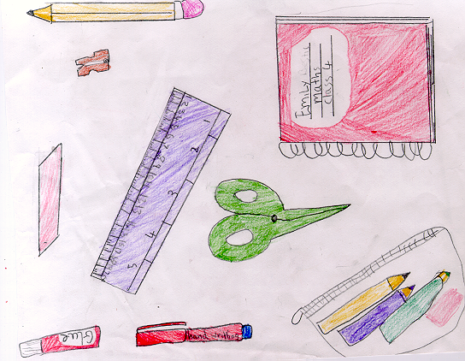
CHARGING POLICY

In keeping with the Education Reform Act of 1988 there are school activities for which we request voluntary contributions. We try to keep the cost of our activities as low as possible. The types of activity for which there would be costs include educational outings to enhance areas of the curriculum and swimming lessons.
No child is denied the opportunity of taking part in any activity because of non-payment, but if insufficient voluntary contributions were received then some activities would not be able to take place. This has never been the case in our school and our activities for which there has been a charge have been well supported by parents.

We request payment in the case of lost or damaged property. Currently we charge £7.00 to cover the cost of a lost or damaged text-book. If text-books come home for home-work will you please make sure that they are treated with respect and returned to school the next day.
Children are asked to come to school with their own pencil cases, pens and pencils. The list includes:
- Good quality HB pencils
- Handwriting pen (Juniors only)
- Fountain pens to be used by years 5 & 6
- Ruler
- Coloured pencils
- Soft rubber
- Pencil sharpener
- Glue stick
- A suitable pencil case/box

Please label all items with your child's name. Please emphasis, as we shall, that these items are for the sole use of your child and are not to be shared with friends.

VOLUNTARY FUND

We ask each family to make a contribution of £9.00 (£15 if they have more than one child in school) to our School Voluntary Fund at the start of each academic year. Cheques should be made payable to Sheldwich Primary School. This money is put toward the cost of special days e.g. Christmas parties, Chinese New Year and Science day. It also enables us to buy prizes for Book week and our popular Easter bonnet competition.
REPORTING TO THE OFFICE

If your child is too ill to attend school please telephone the office by 9.15am on the first morning of their absence, to let the school know the reason for absence. Each school is required to keep records of unexplained absences.

The demand of the National Curriculum mean that children need to attend school on a regular basis. They are then able to work with confidence through their end of Key stage assessments.

With this in mind, we ask for all appointments with doctors and dentists to be made out of school hours. Permission for children to leave school will only be granted in exceptional circumstances, such as appointments with hospital consultants.

We also ask that family holidays are taken during the school holidays. Permission for absence will only be granted in exceptional circumstances and any requests must be made in writing to Mrs Garrett.

The school will consider sympathetically release time requested to cover family emergencies.

We prefer not to administer medicines at school but if we need to do so the medication must be accompanied by written instructions from the parents specifying the medication involved, circumstances under which it should be administered, frequency and level of dosage. We will only administer antibiotics if the dosage is four times a day. If your child has a chronic condition such as asthma, then an inhaler may be kept in the school office. It will need to be clearly labelled with the name of your child. We have eight members of staff who have certificates in First Aid, so there will always be someone on hand to deal with injuries. If children are considered well enough to come to school, then they are considered well enough to go out to play. Cough sweets are not allowed in school.

If you are sending money to school please enclose it in an envelope with the name of your child and the purpose for which the money is being sent clearly written on the front. Could you please put payments for different items in separate envelopes to facilitate our accounting. Wherever possible, to ease administration, all monies should be handed in by your child at registration. However, if this is not possible, there is a red post box in the reception area which is emptied twice daily. At the end of the school day all monies for the day have been accounted for and are ready for banking and it is inconvenient to receive further money at this time.

SCHOOL MEALS

Children may bring in a piece of fruit or vegetable to eat during the morning breaktime as well as a plastic bottle of water to keep in their classroom. Infants are provided with a free piece of fruit or vegetable to eat during afternoon breaktime.

We are fortunate in having meals provided on site, with varied and popular menu options. Payment for these meals must be made in advance either weekly or termly, and can be made by cash or cheque payable to ‘Principals’. Facilities are also provided for children who bring packed meals. If your child is bringing a packed meal we ask that sweets, fizzy drinks or drinks in glass containers are not included. Sweets are not allowed in school. We have two children in school with serious nut and seed allergies so please ensure your child does not have any food containing peanuts and sesame seeds.

If you are on a very low income, you may be able to apply for free school meals. For more information please ask the office staff.

.

POSSESSIONS

Please do not allow your child to bring valuable possessions into school as we cannot be responsible for their safe keeping. It is best if your child does not bring toys or cards into school as these can be damaged or mislaid which can cause distress to your child. Our own playground equipment and wet playtime games are available for the children to play with.

BAD WEATHER PROCEDURE

Rarely, it becomes necessary to close the school because of bad weather, such as heavy snow-falls which make travelling risky. During times of severe weather conditions, please check our website, www.sheldwich.kent.sch.uk which we keep regularly updated. We will also inform local radio stations.

Finally, while our constant aim is the setting of high standards,
we are always considering ways in which we can improve our
provision within a stimulating and happy school environment.
We share our changes with you when they happen.

We hope that your child will be happy in our school!

INFORMATION
Sheldwich Primary School is an ‘Academy School’.

School name and address: Sheldwich Primary School

Lees Court Road, Sheldwich,

Faversham, Kent ME13 0LU
Tel: 01795 532779

Headteacher: Mrs S Garrett BA Ed(Hons), MA, PGCE, NPQH
Chair of Governors: Mr D Milham
School Staff: Deputy Headteacher Mrs A Conroy PGCE/NPQH
KS2 Teachers Miss S Horwood BA Ed (Hons)
Mrs A Puce GLCM PGCE PG Dip PE
Mr J Cork BA (Hons) PGCE
Mrs N Hammond BA ED (Hons)
Mrs E Hodge BA ED (Hons)
KS1 Teachers Miss H Gregory BA Ed (Hons)
Mrs S Morrison BA Ed (Hons)
Miss R Sharp BA Ed (Hons) PGCE
AENCO Mrs C Gower PGCE
Classroom Assistants Mrs C Sherlock, Mrs C Maw, Mrs S Rayner, Mrs A Earle,
Mrs S Heinsen, Mrs C Wildish, Mrs L Osborne,
Mrs S Caldwell, Mrs K Rackham, Mrs F Dixon, Mrs J Pugsley,
Mrs N Bannister, Mr A Thomas, Mrs C Stanton, Mrs S Stears,
School Business Manager Mrs J Linter
School Administrator Mrs K Spencer-Brown
Office Assistant Mrs J Caverly
Caretaker/Cleaner Mr P Ellis
Midday Supervisors Mrs E Hope, Mrs L Osborne, Mrs C Wildish, Mrs J Griffiths
Mrs N Bannister, Mrs L Moon, Mrs C Maw, Mr A Thomas,
Mrs S Murphy

Parents Teacher Association:

Chairman Mr N Holness
Treasurer Mrs S Colyer

School Governors: Independant Governors Mr D Milham (chair of governors)
Community Governors Revd M Johnson (vice chair) Mr F Stoddart
Mr A Golesworthy
Mr G Offord
Parent Governors Mrs S Uberti
Mrs S Higbee
Mr J Culver
Mrs A Monsarrat

Staff Governors Mrs S Garrett
Mrs A Conroy
Miss S Horwood

Clerk to Governors Mrs J Linter

SCHOOL UNIFORM
We encourage the wearing of school uniform in order to give the children a pride in their appearance and in the school. School uniform also gives individual identity on our educational visits. Polo shirts, P.E. shirts, sweatshirts and cardigans should all have the school logo which can be purchased separately from the school office. Items with the logo already embroidered can be purchased at Term Time Uniforms in Faversham.

KS2 Winter Uniform:
Girls: Grey skirt, pinafore dress or smart grey trousers; white blouse; royal blue tie with yellow stripes; royal blue
jumper or cardigan; white or grey socks.
Boys: Grey trousers; white shirt; royal blue sweatshirt, royal blue tie with yellow stripes; grey socks.

KS2 Summer Uniform

Girls: Blue and white checked or striped dress or smart grey shorts with a white, short sleeved shirt (No tie necessary).

Boys: Grey short trousers can be worn, along with a short sleeved white shirt (No tie necessary).

KS1 Winter Uniform:
Girls: Grey skirt, pinafore dress or smart grey trousers; white polo shirt with logo, royal blue
jumper or cardigan with logo; white or grey socks.
Boys: Grey trousers; white polo shirt with logo, royal blue sweatshirt with logo; grey socks.

KS1 Summer Uniform

Girls: Royal blue and white checked or striped dress or smart grey shorts with a whitepolo shirt with logo (no tie

necessary).
Boys: Grey short trousers can be worn, along with a white polo shirt (no tie necessary).
Boys & Girls: Black leather shoes of a sensible design. Trainers are not suitable for school wear. Shoes that fasten with
velcro rather than laces are easier for younger children to manage. Open toe sandals are not permitted.

Physical Education Kit
Boys & Girls: Royal blue shorts; yellow polo shirt with logo; black or white plimsolls and trainers. Junior boys and girls
participating in football require football boots and shin pads. Royal blue jogging trousers and sweatshirts
can be used for games lessons during the autumn and winter.

It is very important that all items of clothing are clearly marked with the child's name. We do not accept responsibility for loss or damage to personal property of pupils. We have a lost property box, but it is much easier to return garments when they are named. Please would you provide a clearly labelled PE bag so that your child's kit can be stored on their peg.

ROLE OF GOVERNING BODY

Governors are appointed for a term of four years. They may be appointed for a further term.

The responsibilities of the Governing Body are to:

- Oversee the general conduct of the school.

- Provide general principles on discipline.

- Have responsibility for the finance delegated by the Local Authority.

- Take part in procedures for selecting staff.

- Decide whether sex education should be provided.

- Ensure that information concerning the school is available to parents.

- Prepare the Annual Report for parents and hold an Annual General Meeting to discuss the report.

- Ensure the National Curriculum is covered appropriately and delivered.

- Ensure that information about pupils' achievement is available to parents and others.

DOCUMENTS

The following documents are available for inspection at the school office by parents on request.

- Statutory Instructions and DFE circulars relating to the National Curriculum.

- Publications of the National Curriculum.

- The Kent Curriculum Statement.

- School Policy Documents.

KENT COUNTY COUNCIL - Education and Libraries

Address: Kent County Council
Area Education Office
Clover House
John Wilson Business Park
Thanet Way
Whitstable, Kent
CT5 3QZ
Tel: 01227 772992

